Figure 7 – 5km Radius around Site
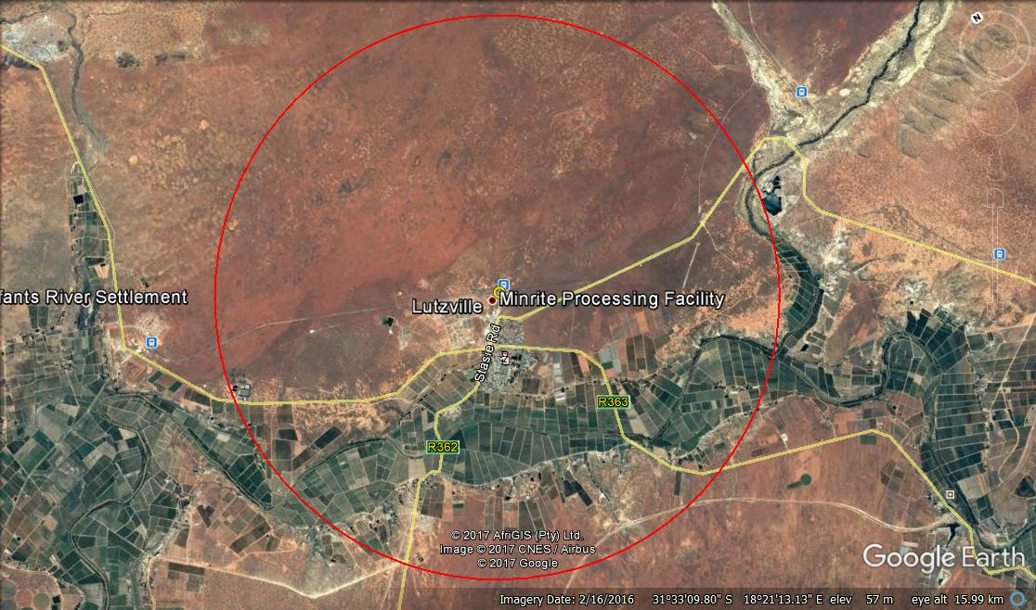
Figure courtesy of Google Earth, 2017

