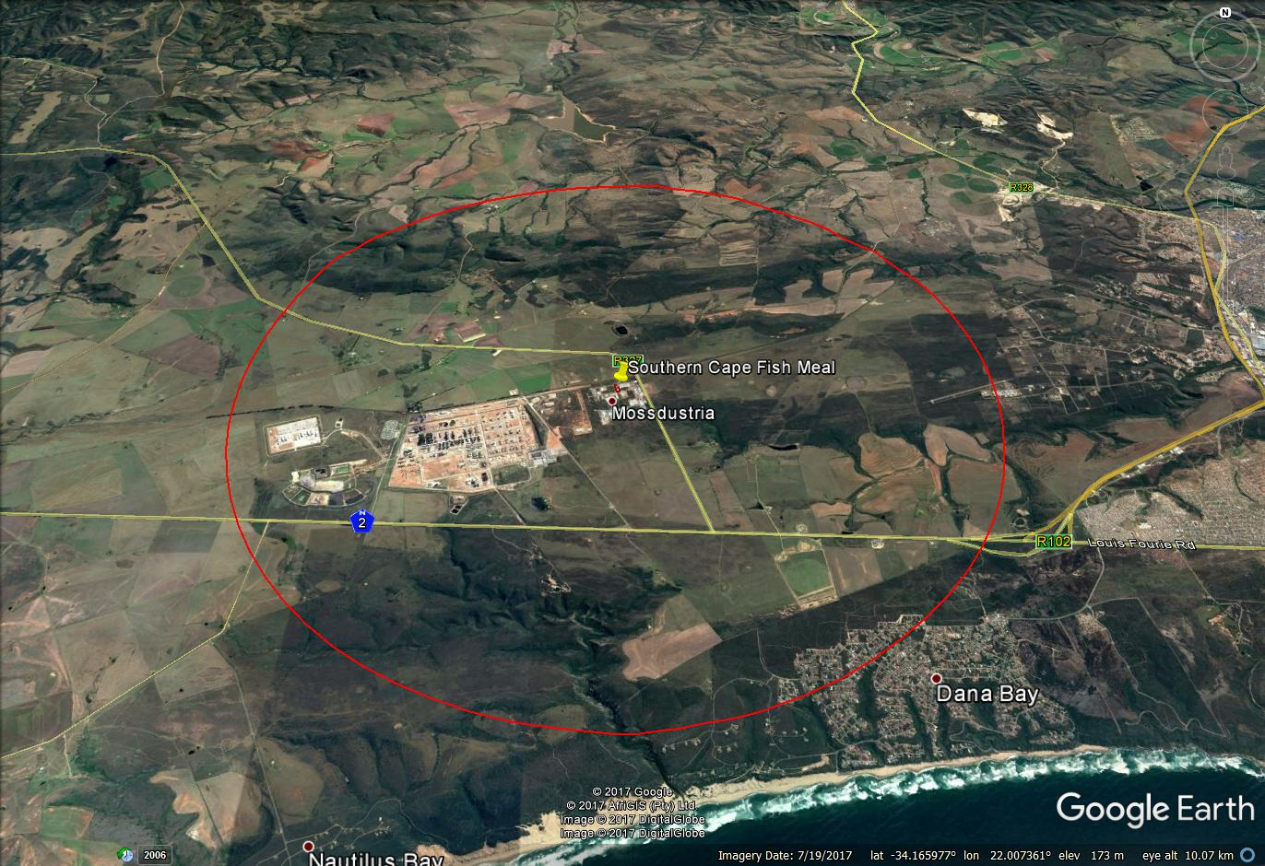

Administration building & convenience store
SEC | CLIENT:  Southern Cape Fish Meal (Pty) Ltd | PROJECT:  017114 SCFM AEL Renewal | TITLE:  5km radius,  Google Earth 2017

