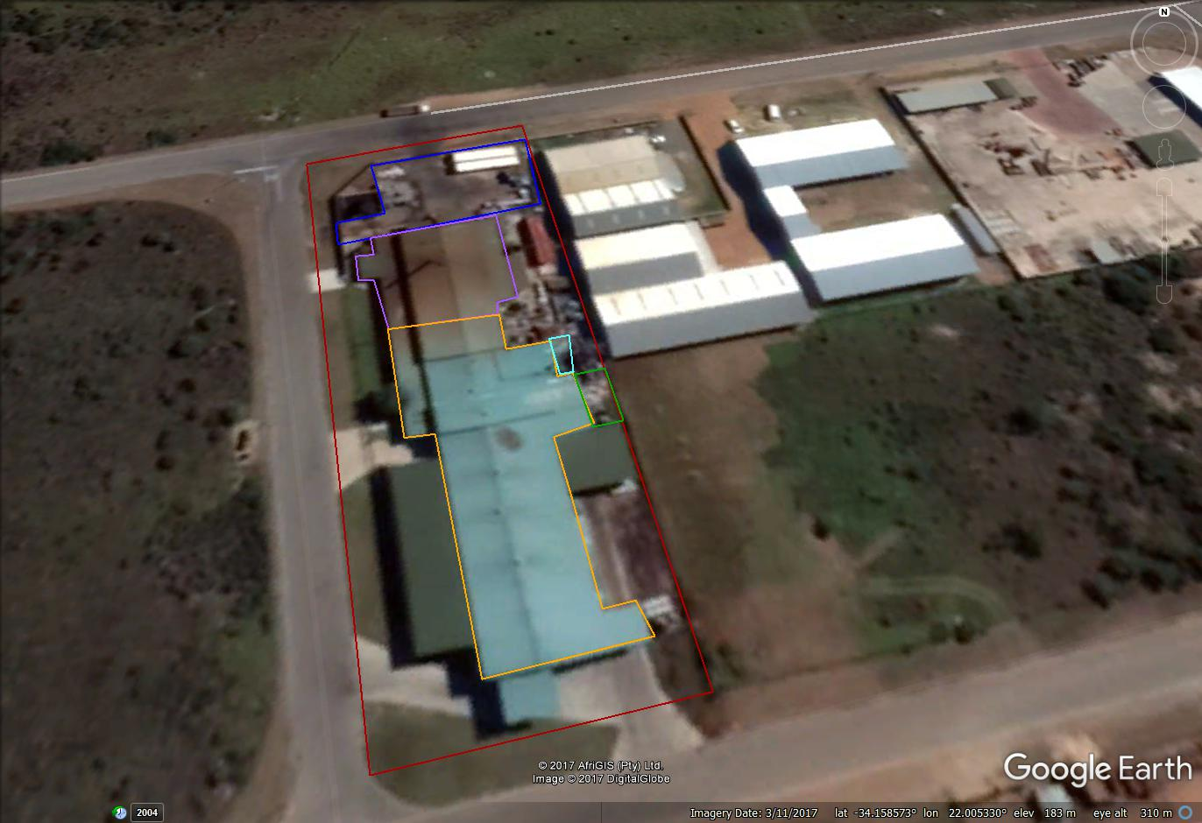
Receiving yard (RG002)
Wastewater treatment plant (EU014)
Stick water plant (RG005)
“Clean” side of building (RG004)
“Dirty” side of building (RG003)
Administration building & convenience store
SEC | CLIENT:  Southern Cape Fish Meal (Pty) Ltd | PROJECT:  017114 SCFM AEL Renewal | TITLE:  Area Source Emissions | DIAGRAM REFERENCE:  Google Earth 2017

