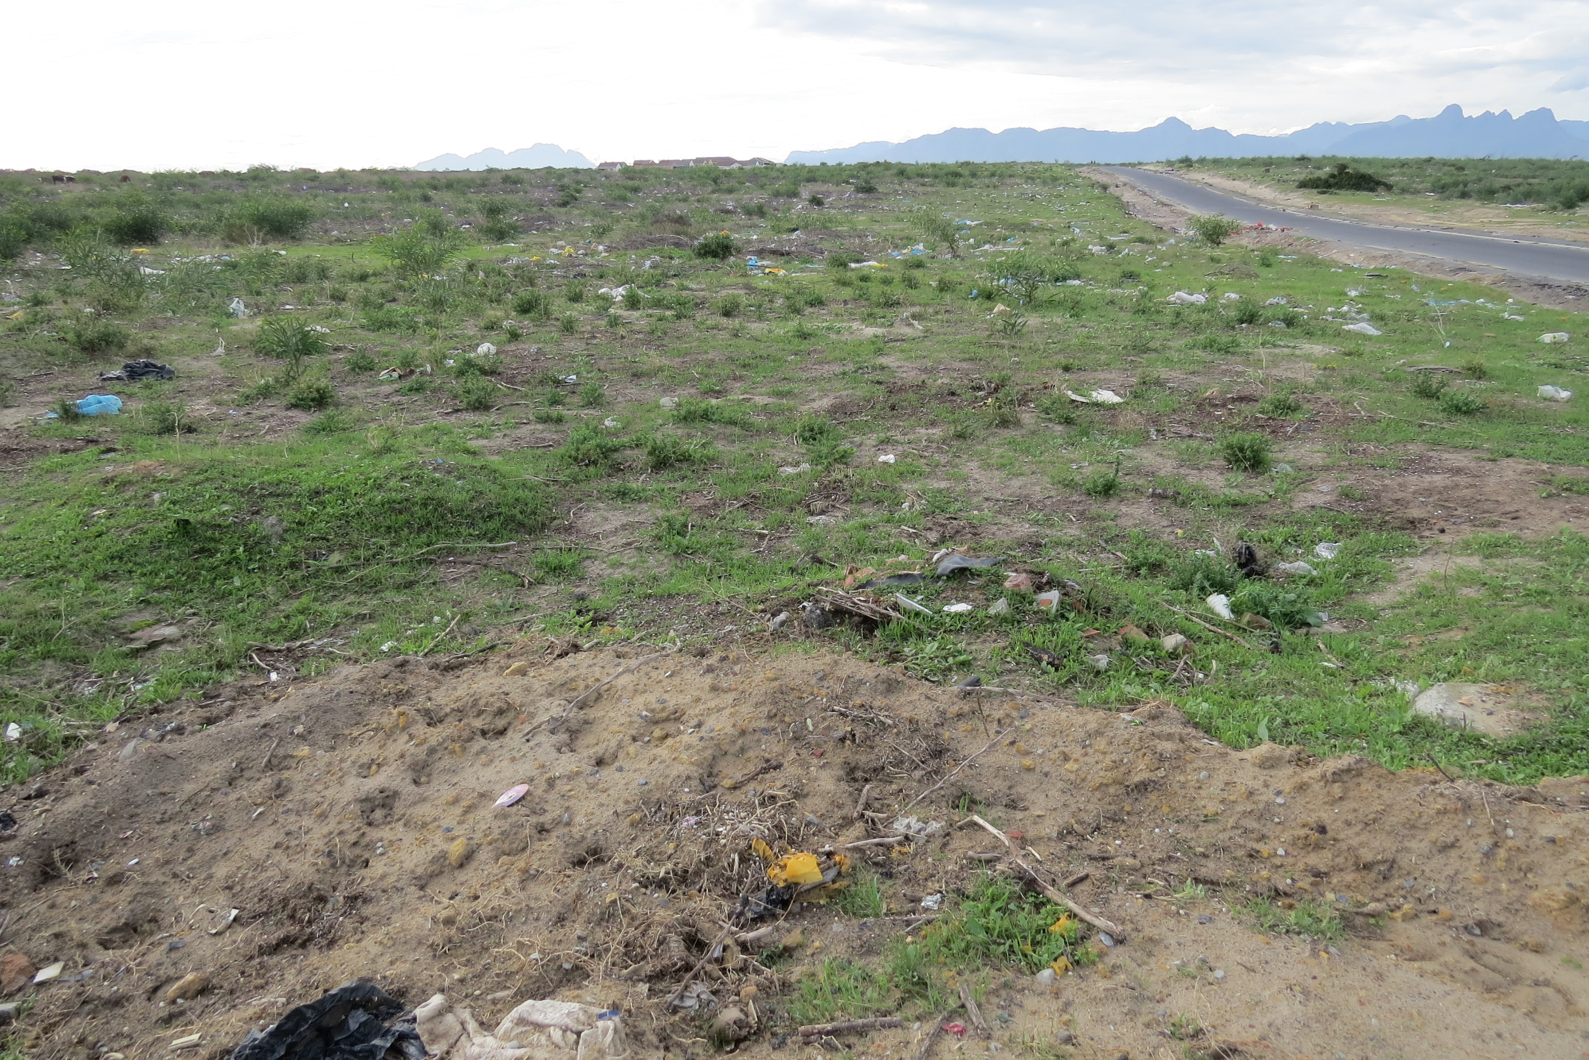  Figure 1: View of site taken in an eastern direction from the access road off Blue Downs Way, showing illegal littering and dumping taking place on site. |  |  | 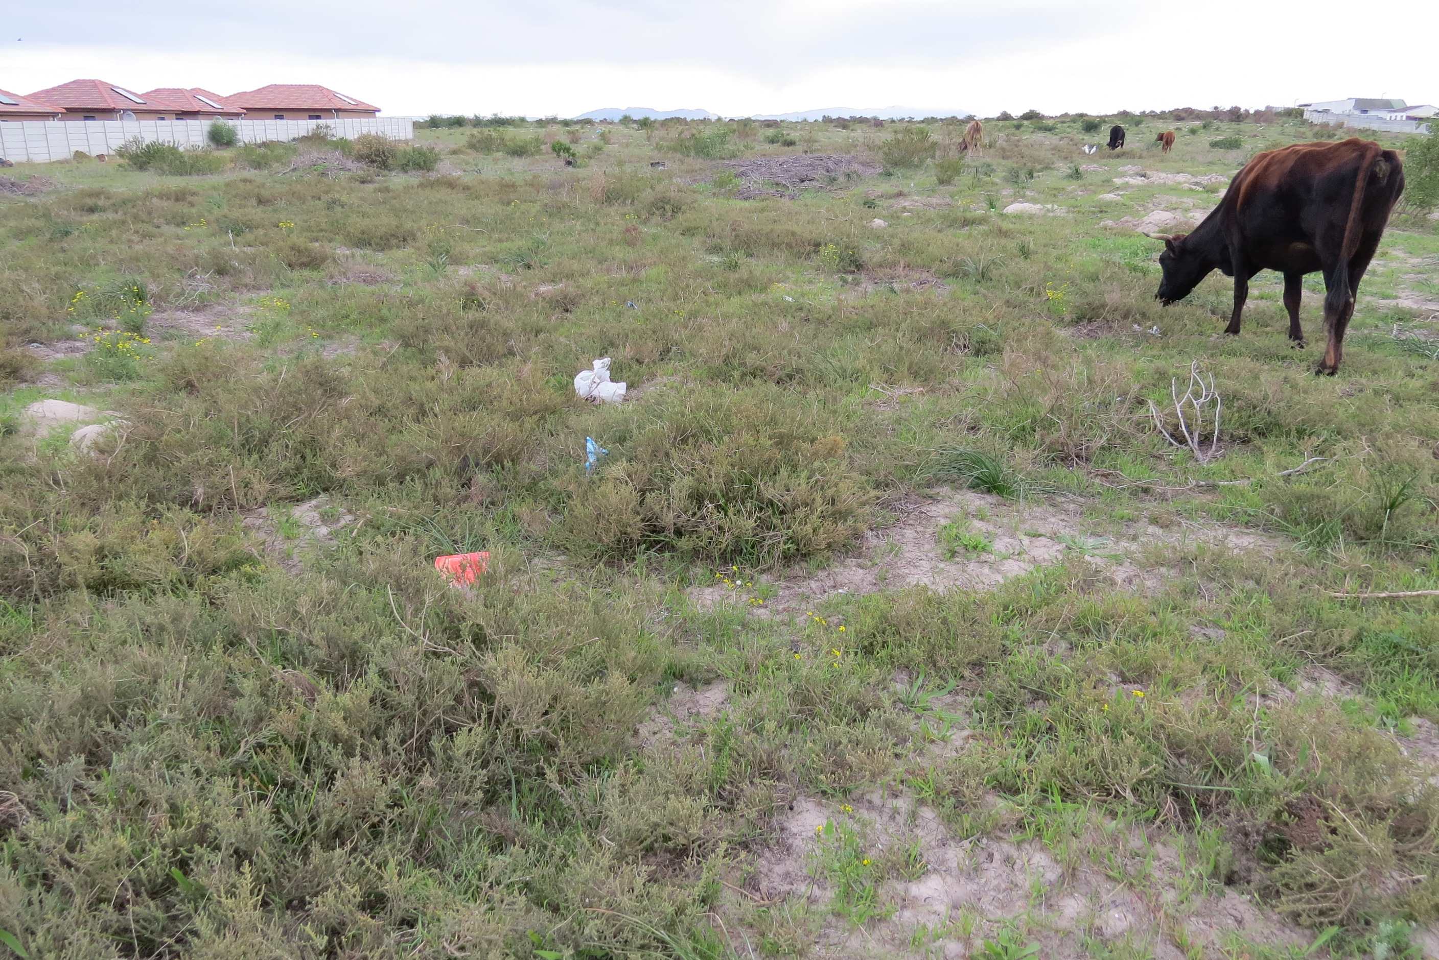  Figure 2: View of site taken in a south-western direction from the north western portion of the site, showing illegal grazing taking place on site.
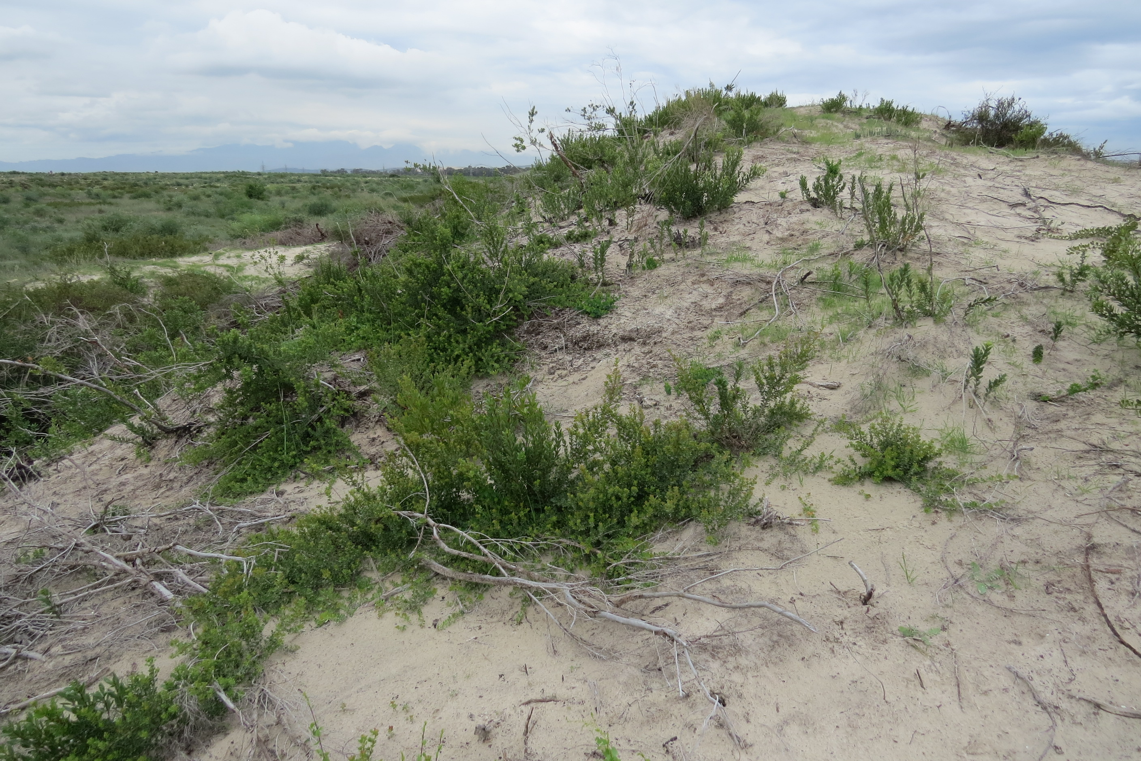  Figure 3: View of dunes on site. |  |  | 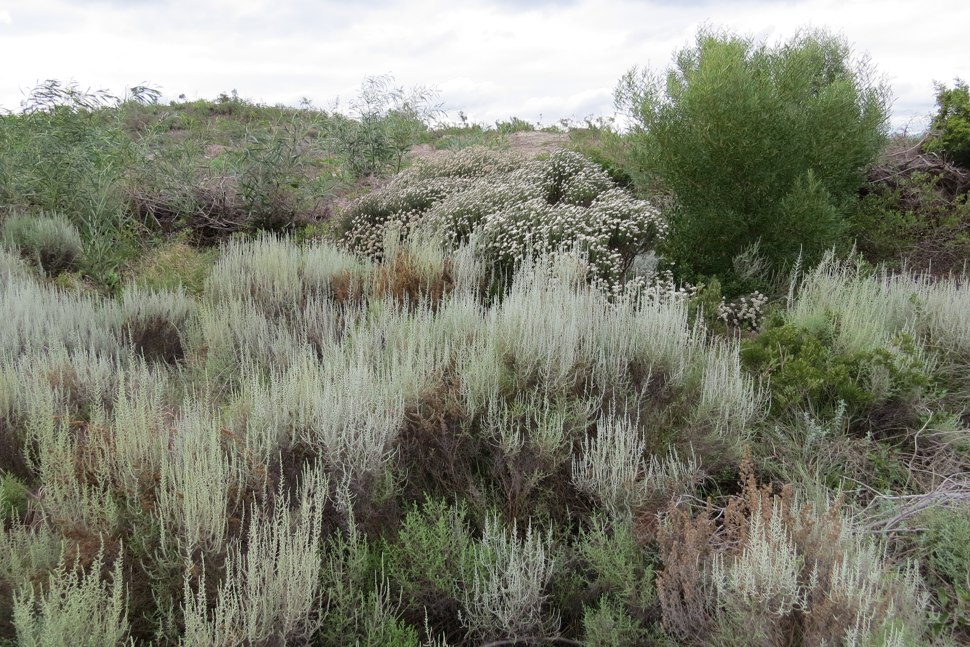  Figure 4: View of intact vegetation on site, towards north western border.
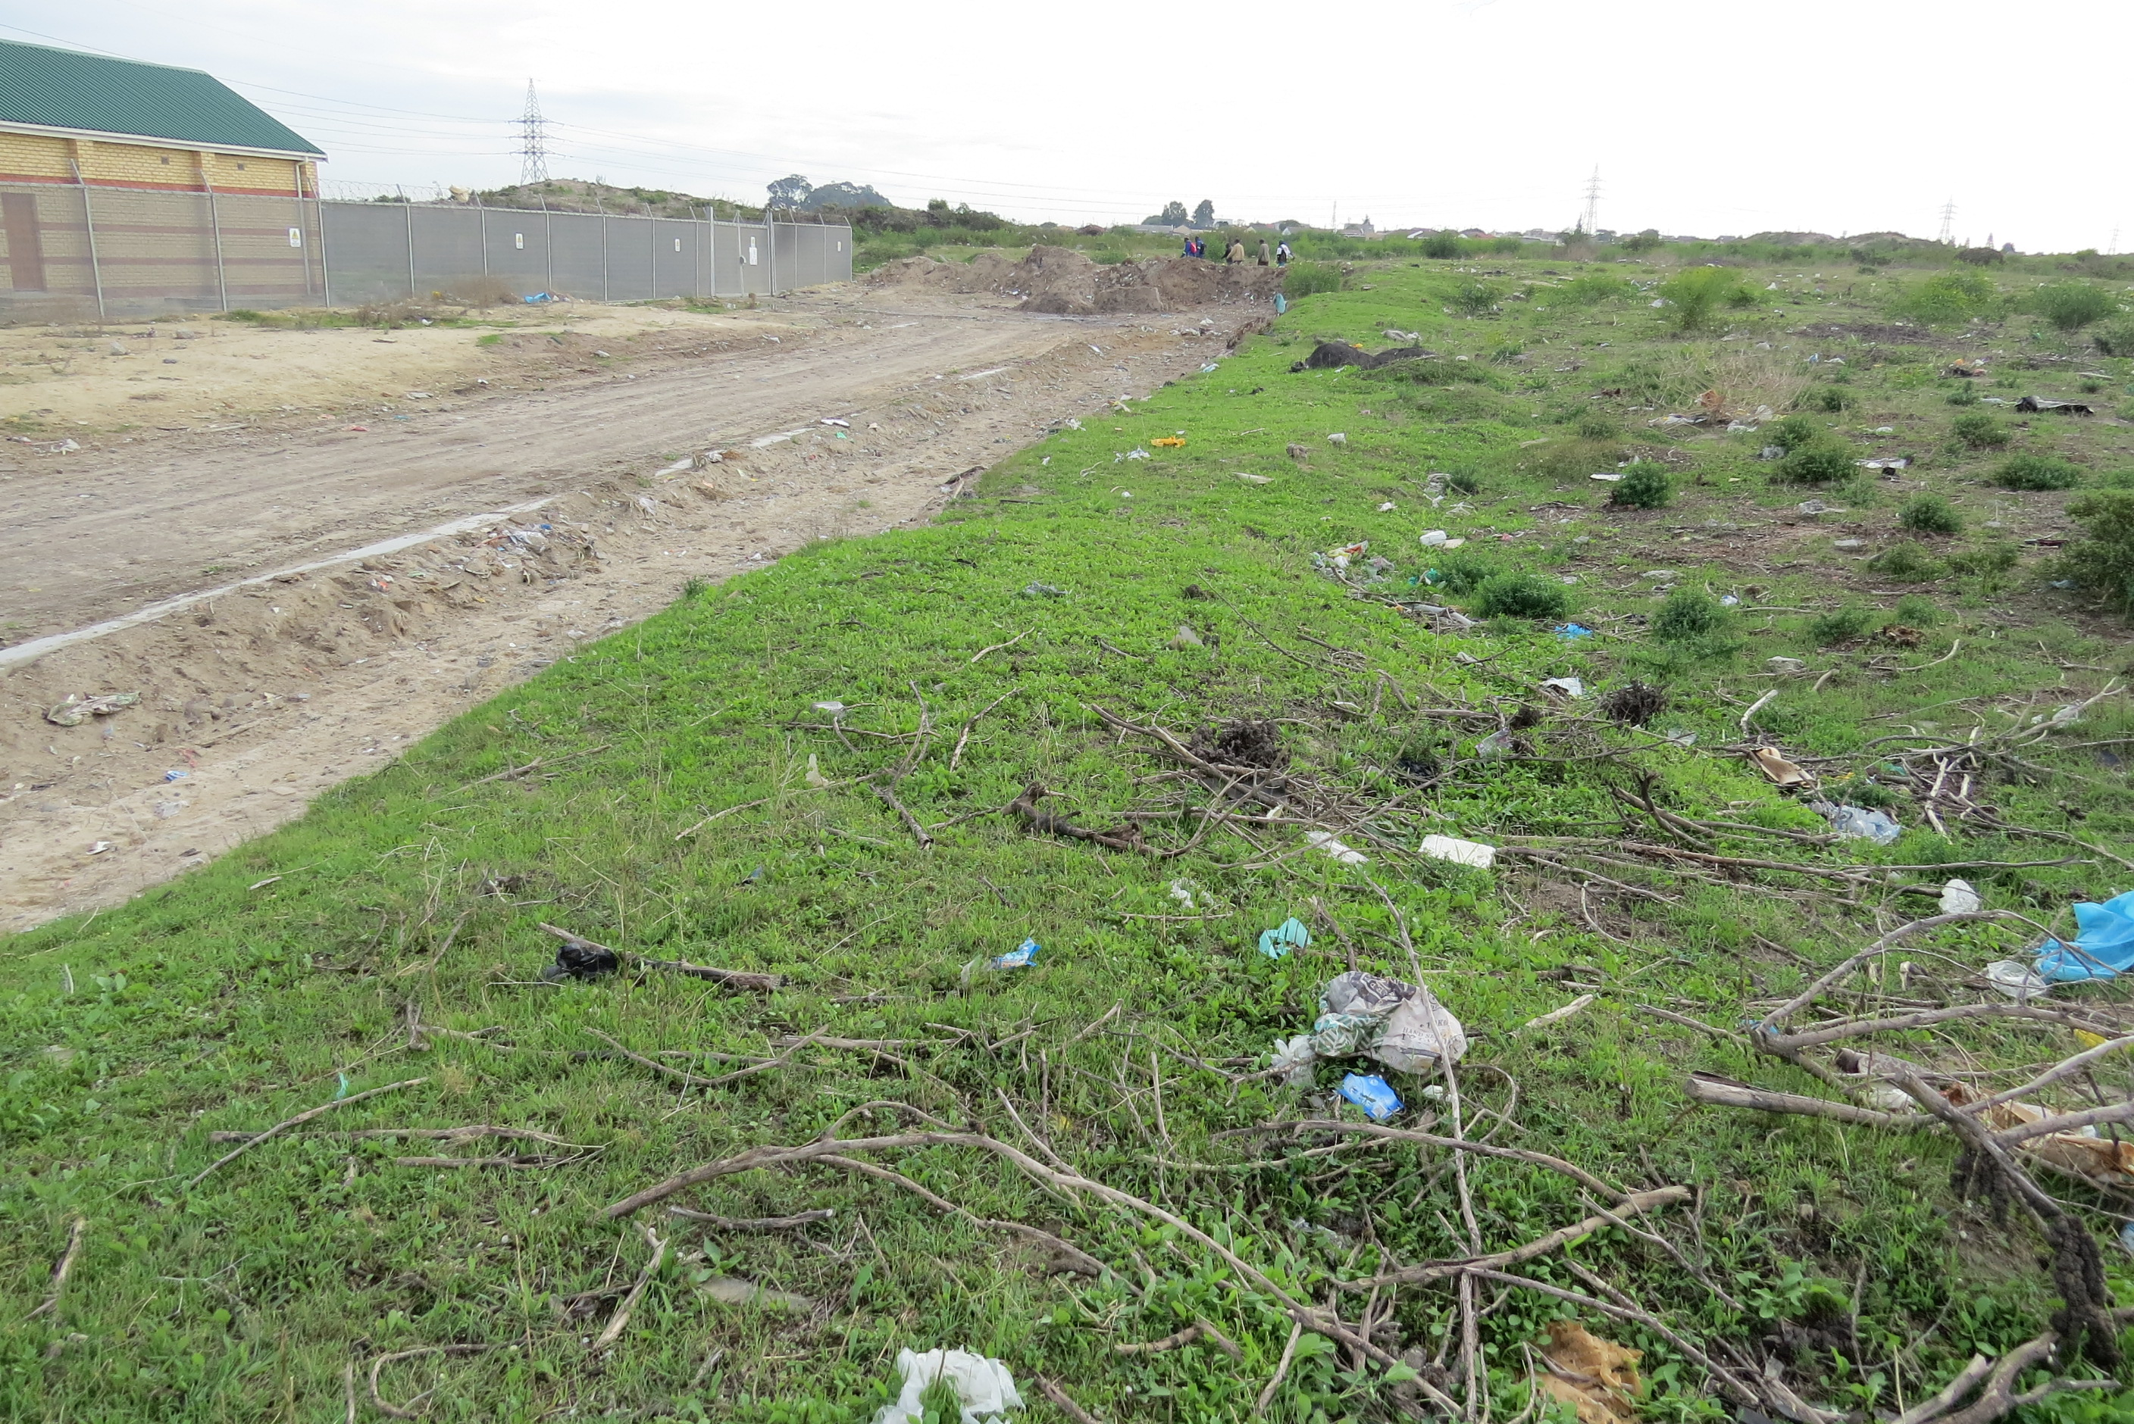  Figure 5: View of the power station, located in middle of the western border of the site, showing littering and illegal dumping taking place on site. |  |  | 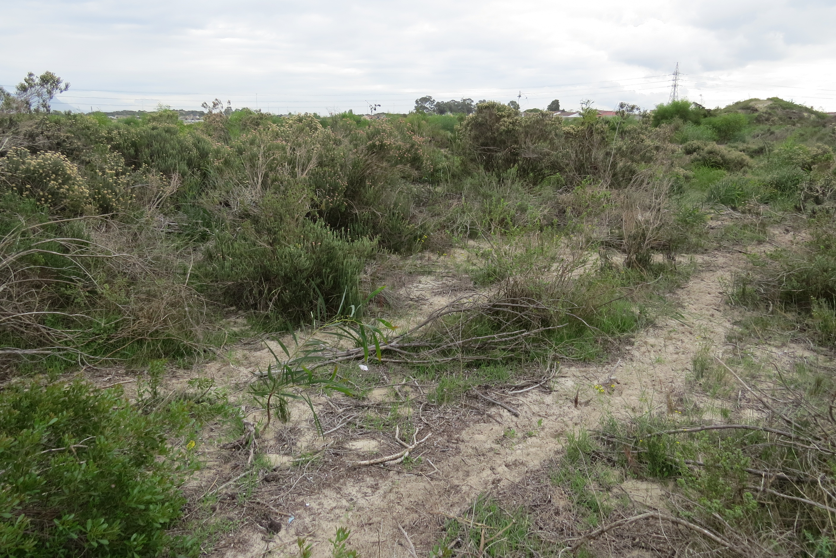  Figure 6: North western border of site.
SEC | CLIENT:  City of Cape Town | PROJECT:  018021 Blueberry Hill | TITLE:  Site Photographs | DRAWING NUMBER:  018021

